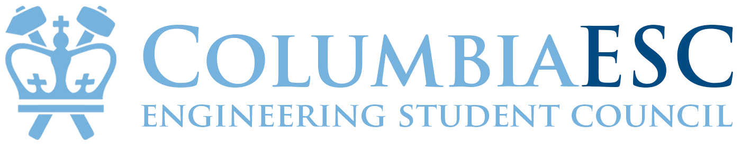
Meeting Agenda and Reports
Monday, September 9, 2019

Upcoming Events / Meetings
- [9/15: Next Sunday Leadership Retreat (Council & Governing Boards)] -- Alina
  - Thank you everyone for RSVPing!
  - 8:00am-5:00pm (brief agenda: breakfast, bouldering, Faculty House meetings, lunch, Advisor meetings -- for those of you new to ESC, this is a good time to understand more about your role!)
  - Meet at 8:00am Lerner Hall 510
- [Committee meetings] -- Alina
  - starting in two weeks (I’ll end meeting early today so y’all can meet w/VP’s & they’ll go over times, groupme’s, etc.)
- [9/16: next g-body]: -- Alina

For any FB Blasting, please put all links here with your name
- Naomi Kim: https://www.facebook.com/events/1210328259172956/?notif_t=plan_user_associated&notif_id=1568056374302088
  - Just Desserts: dessert and networking event for sophomores and juniors
  - September 25, 6:45-8 pm
- Adheli Gonzalez
  - https://www.facebook.com/events/2418587971550169/
  - The Columbia Engineering Student Council has a SEAS major-specific peer mentorship program where underclassmen are paired with a junior/senior with the same major whom they can ask any questions about their Columbia experience. Join the family!

Sign up to be a mentor: https://forms.gle/uQ3E3FrvsePoSDNz5
Sign up to be a mentee: https://forms.gle/Ue99bWqcEiGqy5U26

Have any questions or comments? Contact adheli.gonzalez@columbia.edu.

Discussion Topics
- [Topic] [10 min]
  - Lunch/dinner chats w ESC [5 min] -- Adheli

Position Updates
- Student Body President
  - The ESC Drive (brief overview for everyone)
    - ESC Drive
    - Read Me: ESC Drive
  - UEMS booking
    - Class councils -- you can book for class council events.
    - Reps -- reach out to e-board for any events you need spaces for.
  - Newsletter access & times
    - Alina - biweekly (first one tonight); if you want anything added, please dm/tell me! Req’d: picture + blurb.
    - Sambhav - Biweekly (Weekly morning notifications if an important event in that week) Starts tonight or tuesday morning
    - Kalisa - Biweekly (First one tomorrow afternoon)
    - Naomi - biweekly (first one next Sunday)
  - Facebook Group access
    - Adheli - moderates all 4 facebook groups
    - Sambhav, Kalisa, Naomi -- moderates respective class groups
  - Enough is Enough/Mental Health Training
    - Tues 9/17: make-up session
  - Coming up: The Food Pantry will speak to us! (next gbody, or next next gbody)
- VP Policy
  - Designated Committees for each Representative
    - Designated Reps on Committees
  - ESC Points of Contact
    - **Important: ESC Points of Contact (administration)
  - Coming up: Robert’s Rules of Order overview
  - Committee members: Estevan Mesa, Georgia Fujita, Kalisa Ndamage, Young Jae Ryu, Joe Hier, James Wang, Ade Balogun, Rahul Kataria, Sebastian Sanchez, Dianna Carranza, Naomi Kim, class of 2023 member Alina Ying
- VP Student Life
  - Meeting with other Student Life VPs and advisers
  - Points System overview
  - Coming up: Homecoming Pep Rally, completed Points System
  - Committee members: Ahmet Karadeniz, Alison Selman, Arya Zhao, Josh Guggenheim, Katherine Liu, Nick Mijares, Will Fesjian, class of 2023 member, Alina Ying
- VP Finance
  - F@CU
    - F@CU 2019 Folder
  - Bacchanal Governing Board
  - JCCC on the 29th
  - Initiative fund
  - Coming up: trying to work more with the governing boards, Bacchanal MOU
  - Committee members: Jenny Martinez, Eugene Fung, Can Akdere, Lal Uncu, class of 2023 member, Alina Ying
- VP Communications
  - Website: registered domain w/Josh Lucas as website sponsor on Columbia servers (sites@columbia). Old esc & finance websites being hosted on AWS are being shut down. Publishing date tba.
  - Peer Mentorship Program applications released. Added more subcategories.
  - Committee members: Ethan T, Rahul Kataria, Stephanie Guo, Sambhav Jain, class of 2023 member, Alina Ying
- University Senator
  - SAC retreat
  - Looking for Interschool Governing Board (IGB) SEAS delegate
- Class of 2020
  - Search for Class Day speaker has begun. Few names are: Sheryl Sandberg, Marc Benioff, Bob Bakish, Andrew Yang. Open to any suggestions!! :)
  - Meeting CCE this week
  - CCSC president and I will go through alcohol training this week. After that, first Lerner pub planning
  - Dean’s Welcome Reception next week on Sept 19
- Class of 2021
  - 3-2 Mixer Wednesday 9/11 if we can order food.
  - Just Dessert next week
- Class of 2022
  - Just Desserts coming up, sending the first newsletter next week
  - Meeting with advisor soon...hopefully
- Class of 2023

- Technology Representative

- Racial Diversity and Inclusivity Representative

- Gender Identity and Sexuality Representative

- First Gen and Low Income Representative

- Disability and Accessibility Issues Representative

- Academic Affairs Representative

- Student Groups Representative

- Sustainability Representative

- Professional Development Representative

- Campus Affairs Representative

- Student Services Representative

- International Students Representative

- Combined Plan 3-2 Representative
  - 3-2 Mixer Wednesday 9/11

